LIBRARY MANAGEMENT SYSTEM
A DBMS Capstone Project Report submitted in partial fulfillment of the requirements for the award of the degree of
BACHELOR OF TECHNOLOGY
in
ARTIFICIAL INTELLIGENCE AND MACHINE LEARNING

Submitted By
B VYAS SRI NANDAN – 25B11AI130
MOLLETI RAVI TEJA – 25B11AI755
CH SAI KARTHIKEYAN – 25B11AI216
K A V MANIKANTA – 25B11AI589

Under the esteemed guidance of
Mr. T.Srinivasulu M.Tech, (Ph.D.)
Assistant Professor



DEPARTMENT OF ARTIFICIAL INTELLIGENCE AND MACHINE LEARNING
ADITYA UNIVERSITY
(Formerly Aditya Engineering College (A))
Aditya Nagar, ADB Road, Surampalem, Andhra Pradesh, India
2026 – 2027

Aditya Nagar, ADB Road, Surampalem, Andhra Pradesh, India
DEPARTMENT OF ARTIFICIAL INTELLIGENCE AND MACHINE LEARNING
CERTIFICATE
This is to certify that the DBMS Capstone Project report entitled “LIBRARY MANAGEMENT SYSTEM” is being submitted by B.VYAS SRI NANADAN (Roll No. 25B11AI130), M.RAVI TEJA (Roll No. 25B11AI755 ), CH.SAI KARTHIKEYAN (Roll No. 25B11AI216 ) and K.ANJANEYA VENKATA MANIKANTA (Roll No. 25B11AI589 ) in partial fulfillment of the requirements for the award of the B.Tech. degree in Artificial Intelligence and Machine Learning. The work documented in this report was carried out as part of the Capstone Project for the course Database Management Systems (2501IT05) during the academic year 2026–2027, and records the database design, implementation, and documentation undertaken by the team.

Project Guide Head of the Department
Mr. T. Srinivasulu, M. Tech, (Ph.D.) Dr. K. Naga Bhargavi, M. Tech, Ph.D. Assistant professor Associate Professor & HOD

External Examiner


DECLARATION
We hereby declare that the DBMS Capstone Project entitled “ LIBRARY MANAGEMENT SYSTEM ” is a genuine work carried out by us. The database design, SQL implementation, queries and documentation presented in this report are our own work, completed under the guidance of Mr. T. Srinivasulu, M. Tech, (Ph.D.), Department of ARTIFICIAL INTELLIGENCE AND MACHINE LEARNING, Aditya University, Surampalem. We further declare that this work has not been submitted, in full or in part, for the award of any degree of this or any other educational institution.

Project Associates
B VYAS SRI NANDAN ( 25B11AI130 )
MOLLETI RAVI TEJA ( 25B11AI755 )
CH SAI KARTHIKEYAN ( 25B11AI216 )
K A V MANIKANTA ( 25B11AI589 )

Date: 14 September 2026
Place: Surampalem

ACKNOWLEDGEMENT
It is with immense pleasure that we express our indebted gratitude to our project guide Mr. T. Srinivasulu, M. Tech, (Ph.D.) , Department of ARTIFICIAL INTELLIGENCE AND MACHINE LEARNING , who guided us throughout the capstone project. We are thankful for the constant encouragement and valuable suggestions received at every review stage.
We are grateful to Dr. K. Naga Bhargavi, M.Tech, Ph.D , Head of the Department, for inspiring us and for arranging the facilities and resources needed for this project.
We extend our sincere thanks to the Management, Dr. M. Sreenivasa Reddy, Deputy Pro-Chancellor, Dr. M. B. Srinivas, Vice-Chancellor, and Dr. A. Ramesh, Pro Vice-Chancellor (Engineering & Sciences), for providing an excellent academic environment.
Not to forget, we thank the Teaching and Non-Teaching Staff, our parents and our friends, who have directly or indirectly supported us in completing this project on time.

Project Associates
MOLLETI RAVI TEJA Regd. No. 25B11AI755
CH SAI KARTHIKEYAN Regd. No. 25B11AI216
B VYAS SRI NANDAN Regd. No. 25B11AI130
K A V MANIKANTA Regd. No. 25B11AI589

ABSTRACT
The Library Management System (LMS) is a comprehensive, production-grade relational database solution designed to automate, streamline, and govern the operational workflows of an academic institutional library. Built on MySQL 8.0, the system comprises nine interrelated entities — STUDENT, BOOK, AUTHOR, PUBLISHER, CATEGORY, LIBRARIAN, BOOK_AUTHOR, ISSUE, and FINE — fully normalized to Third Normal Form (3NF) to eliminate data redundancy and update anomalies. The database enforces comprehensive integrity constraints including PRIMARY KEY, FOREIGN KEY, UNIQUE, NOT NULL, CHECK, and DEFAULT clauses across all nine tables. Key features include automated inventory synchronization via MySQL triggers, ACID-compliant transaction management using COMMIT, SAVEPOINT, and ROLLBACK, four operational views (AVAILABLE_BOOKS, CURRENT_ISSUES, STUDENT_ISSUE_HISTORY, FINE_DETAILS), multi-table JOIN queries, aggregate reporting, and correlated subqueries. The project is version-controlled on GitHub and documented with an ER diagram, relational schema, complete DDL/DML/DQL scripts (896 lines across 17 parts), and this academic report. This system demonstrates applied relational database design principles and SQL proficiency for real-world library administration.

INDEX

Chapter | Title | Page No.
 | Certificate | 1
 | Declaration | 2
 | Acknowledgement | 3
 | Abstract | 4
 | List of Figures | 6
 | List of Tables | 6
1 | Introduction
 | 1.1 Introduction to the Domain | 7
 | 1.2 Problem Statement | 7
 | 1.3 Motivation and Need for a Database | 7
 | 1.4 Objectives of the Project | 8
 | 1.5 Scope of the Project | 8
 | 1.6 Organization of the Report | 9
2 | System Study and Tools
 | 2.1 Existing System and Its Limitations | 10
 | 2.2 Proposed Database System | 10
 | 2.3 Tools and Technologies Used | 10
 | 2.4 Software and Hardware Requirements | 11
3 | Database Design (Review – I)
 | 3.1 Identified Entities | 12
 | 3.2 Entity Attributes and Attribute Types | 12
 | 3.3 ER Diagram | 13
 | 3.4 Relationships and Cardinality | 14
 | 3.5 Relational Database Schema | 14
 | 3.6 Primary Keys and Foreign Keys | 16
 | 3.7 Normalization up to 3NF | 17
4 | Database Implementation (Review – II)
 | 4.1 Database and Table Creation – DDL | 18
 | 4.2 Sample Data Insertion – DML | 20
 | 4.3 Constraints and Data Integrity | 22
 | 4.4 Data Validation Rules | 22
5 | SQL Operations and Queries
 | 5.1 DQL – Basic Retrieval Queries | 23
 | 5.2 Join Operations | 23
 | 5.3 Aggregate Functions, GROUP BY and HAVING | 23
 | 5.4 Nested and Correlated Subqueries | 24
 | 5.5 Views and Relational Set Operations | 24
 | 5.6 DCL and TCL Operations | 25
6 | Modules and Functionalities | 26
7 | Results – Sample Outputs and Screenshots | 27-30
8 | Testing and Data Validation | 31
9 | GitHub Repository and Team Contribution | 32
10 | Conclusion and Future Enhancements | 33
 | References | 33
 | Appendix A – Complete SQL Script | 34-39
LIST OF FIGURES

LIST OF TABLES
Figure No. | Title of the Figure | Page No.
3.1 | ER Diagram of the Library Management System | 13
3.2 | Relational Schema Diagram | 16
4.1 | Successful Creation of Tables | 20
4.2 | Sample Data Inserted into the Tables | 20
4.3 | Referential Integrity Enforced by the Database | 22
7.1 | Active Master Catalog and Available Copy Status | 27
7.2 | Execution of IssueBook Procedure and Trigger Inventory Synchronization | 28
7.3 | Patron Fine Summary and Overdue Audit Report | 29
7.4 | Referential Integrity and Domain Check Constraints Enforced by MySQL Engine | 30
Table No. | Title of the Table | Page No.
2.1 | Tools and Technologies Used | 10
2.2 | Software and Hardware Requirements | 11
3.1 | Entities Identified for the Selected Domain | 12
3.2 | Attributes of Each Entity | 12
3.3 | Relationships and Cardinality | 14
3.4 | Relational Database Schema | 14
3.5 | Primary Key and Foreign Key Definitions | 16
3.6 | Normalization Steps | 17
4.1 | Sample Data Summary | 20
4.2 | Constraints and Data Integrity Rules | 22
5.1 | Basic Retrieval Queries | 23
5.2 | Join Operations | 23
5.3 | Aggregate, GROUP BY and HAVING Queries | 23
5.4 | Subqueries | 24
5.5 | Views and Set Operations | 24
5.6 | DCL and TCL Operations | 25
6.1 | Modules and Their Functionalities | 26
8.1 | Test Cases and Results | 31
9.1 | Team Responsibilities | 32
9.2 | Review-wise Progress Record | 32

CHAPTER 1: INTRODUCTION

1.1 Introduction to the Domain
An institutional library serves as the intellectual hub of an academic organization, providing crucial learning resources, specialized textbooks, research journals, and reference materials to students, faculty members, and research scholars. On a day-to-day basis, an academic library oversees extensive inventories of physical media across various academic disciplines, requiring systematic tracking of accessions, editions, publishing houses, and multi-author attributions. The primary operational workflows involve patron registration, book circulation (issue and check-in workflows), due-date tracking, reservation queues, and fine collection for overdue loans.
Beyond core book lending, modern academic libraries handle substantial administrative metadata, including unique patron identity cards, borrowing threshold allocations, shelf and genre classifications, and historical transaction logs. Sustaining this operational ecosystem requires concurrent transactions where borrowing checkouts, real-time inventory adjustments, and penalty receipts occur simultaneously across circulation counters and self-service digital access points.

1.2 Problem Statement
Historically, academic libraries relied on manual physical ledgers or decentralized flat spreadsheets to record circulation and catalog details. This legacy approach presents severe technical drawbacks:
- Data Redundancy and Inconsistency: Member profiles, author biographies, and publisher contact data are re-typed across multiple issue records, causing data duplication and inconsistencies.
- No Real-Time Integrity or Concurrency Control: Spreadsheets lack automated relational integrity. If a member profile is removed, associated loan records become orphaned. Furthermore, concurrent checkouts lead to race conditions where two members borrow the final copy of a book at the same time.
- Inefficient Retrieval and Penalty Tracking: Locating available titles, computing fine amounts based on overdue days, or analyzing popular genres requires manual lookups, resulting in administrative delays and human error.
The proposed Library Management System addresses these issues by deploying a centralized, normalized relational database engine built on MySQL 8.0. It enforces ACID-compliant transactions, hard database constraints, trigger-based inventory adjustments, and dynamic view calculations.

1.3 Motivation and Need for a Database
A dedicated Database Management System (DBMS) is essential for an institutional library for several reasons:
- ACID Transaction Guarantees: Circulation operations (such as borrowing a book) require multi-table updates (logging the loan, decrementing available stock) that must succeed or fail as an atomic unit.
- Native Constraint Enforcement: A DBMS enforces domain validation (PRIMARY KEY, FOREIGN KEY, CHECK, UNIQUE, NOT NULL) at the storage engine level, preventing negative inventory, invalid loan dates, or duplicate IDs.
- High Concurrency and Security: Through row-level locking and role-based access controls, a DBMS supports simultaneous operations by multiple librarians without data race conditions, while protecting member privacy.
- Fast Query Optimization: Utilizing B-Tree indexing on primary and foreign keys allows instant search across large book catalogs and historical logs.

1.4 Objectives of the Project

To design a normalized relational database schema adhering to Third Normal Form (3NF) containing core library entities to eliminate update, insertion, and deletion anomalies.

To implement declarative database integrity using PRIMARY KEY, FOREIGN KEY, NOT NULL, UNIQUE, and CHECK constraints across all tables.

To develop automated database triggers for inventory synchronization (decrementing and incrementing available copies upon issue and return) and automatic overdue fine computation.

To implement ACID-compliant transaction blocks using START TRANSACTION, SAVEPOINT, COMMIT, and ROLLBACK for book issue workflows.

To construct advanced SQL queries incorporating inner/outer joins, aggregate reporting, correlated subqueries, and database views for institutional reporting.

1.5 Scope of the Project
What the Database Covers:
- Complete lifecycle tracking of physical books, authors, publishers, and genre categories.
- Patron/Member record management with maximum borrowing quotas and membership tracking.
- Staff oversight tracking librarian roles and operational shifts.
- Circulation management (issue date, due date, check-in date, fine logging).
What the Database Does Not Cover:
- Physical RFID security gate hardware integration and barcode scanner firmware.
- Digital Rights Management (DRM) and hosting of encrypted e-books or digital PDFs.
- External bank payment gateway handshakes for online fine collection.

1.6 Organization of the Report
This report is organized into ten chapters. Chapter 2 presents the system study and tools used. Chapter 3 covers the complete database design including the ER diagram, relational schema, and 3NF normalization. Chapter 4 describes the database implementation with DDL and sample data. Chapter 5 presents the SQL operations and queries executed. Chapter 6 explains the modules and functionalities. Chapter 7 presents results with sample outputs. Chapter 8 covers testing and data validation. Chapter 9 details the GitHub repository and team contributions. Chapter 10 concludes the report and outlines future enhancements.

CHAPTER 2: SYSTEM STUDY AND TOOLS

2.1 Existing System and Its Limitations
The existing system relies on manual records or unlinked desktop spreadsheets. Its primary limitations are:
- Update Anomalies: Updating a publisher's contact phone or an author's name requires manual edits across multiple rows, leading to data divergence.
- Deletion Anomalies: Deleting the last copy of a book written by an author removes the author's contact and biographical information if stored in a single table.
- Insertion Anomalies: A newly registered publisher cannot be stored in the catalog until an actual book printed by that publisher is acquired.
- Lack of Audit Trails: Spreadsheets can be edited directly without preserving transaction history or accountability.

2.2 Proposed Database System

The proposed relational database system segregates master entities (MEMBER, BOOK, AUTHOR, PUBLISHER, STAFF) from transaction tables (TRANSACTION) and associative tables (BOOK_AUTHOR).

Eliminates redundancy and anomalies via a 3NF normalized structure.

Guarantees catalog integrity using database triggers that adjust available copies automatically.

Protects transactional integrity using explicit transaction boundaries (COMMIT and ROLLBACK).

2.3 Tools and Technologies Used
Table 2.1: Tools and Technologies Used
Category | Tool / Technology Used | Version / Remarks
Database Server | MySQL Community Server | Version 8.0.36; provides InnoDB engine with full ACID compliance.
Admin & Query Tool | MySQL Workbench / CLI | Version 8.0; used for visual schema mapping, query profiling, and script execution.
ER Diagram Tool | Diagrams.net (Draw.io) | Cloud Web App; used for Chen-notation ER and relational mapping.
Data Generation | Python (Faker & csv) | Version 3.11; automated synthetic generation of test datasets.
Version Control | Git & GitHub | Distributed version control repository hosting DDL, DML, and documentation.
Documentation | Microsoft Word | Technical report documentation adhering to university templates.

2.4 Software and Hardware Requirements
Table 2.2: Software and Hardware Requirements
Requirement Type | Specification
Operating System | Windows 10/11 (64-bit), Ubuntu 22.04 LTS, or macOS Sonoma
Database Platform | MySQL Server 8.0+ running on local port 3306
Processor | Intel Core i3 / AMD Ryzen 3 or higher (2.0 GHz multi-core)
RAM (Memory) | Minimum 4 GB RAM (8 GB recommended)
Disk Storage | Minimum 500 MB free space for tablespaces, logs, and mock datasets

CHAPTER 3: DATABASE DESIGN
(Deliverables of Review – I)

3.1 Identified Entities
Table 3.1: Entities Identified for the Selected Domain
S.No | Entity Name | Description
 | BOOK | Represents items in the library catalog with title, genre, year, and stock.
 | AUTHOR | Represents creators of books, storing names and nationality.
 | PUBLISHER | Stores details of printing and distribution houses.
 | MEMBER | Holds library patron profiles, membership dates, and borrowing quotas.
 | STAFF | Represents librarians and employees managing circulation counters and shifts.
 | TRANSACTION | Transactional entity recording book issue, due dates, return dates, and fines
 | BOOK_AUTHOR | Associative entity resolving many-to-many relationship between books and authors

3.2 Entity Attributes and Attribute Types
Table 3.2: Attributes of Each Entity
Entity | Attribute | Data Type | Key (PK / FK / —) | Attribute Type
BOOK | Book_ID | INT | PK | Simple
 | Title | VARCHAR(150) | — | Simple
 | Genre | VARCHAR(50) | — | Simple
 | Publication_Year | INT | — | Simple
 | Total_Copies | INT | — | Simple
 | Available_Copies | INT | — | Derived
 | Publisher_ID | INT | FK | Simple
AUTHOR | Author_ID | INT | PK | Simple
 | First_Name | VARCHAR(50) | — | Simple
 | Last_Name | VARCHAR(50) | — | Simple
 | Nationality | VARCHAR(50) | — | Simple
PUBLISHER | Publisher_ID | INT | PK | Simple
 | Publisher_Name | VARCHAR(100) | — | Simple
 | Contact_Number | VARCHAR(15) | — | Simple
 | City | VARCHAR(50) | — | Simple
MEMBER | Member_ID | INT | PK | Simple
 | Full_Name | VARCHAR(100) | — | Simple
 | Email_Address | VARCHAR(100) | — | Simple
 | Membership_Date | DATE | — | Simple
 | Max_Books_Allowed | INT | — | Simple
STAFF | Staff_ID | INT | PK | Simple
 | Name | VARCHAR(100) | — | Simple
 | Role | VARCHAR(50) | — | Simple
 | Shift_Timing | VARCHAR(30) | — | Simple
TRANSACTION | Transaction_ID | INT | PK | Simple
 | Book_ID | INT | FK | Simple
 | Member_ID | INT | FK | Simple
 | Staff_ID | INT | FK | Simple
 | Issue_Date | DATE | — | Simple
 | Due_Date | DATE | — | Simple
 | Return_Date | DATE | — | Simple (Nullable)
 | Fine_Amount | DECIMAL(8,2) | — | Derived
BOOK_AUTHOR | Book_ID | INT | PK, FK | Simple
 | Author_ID | INT | PK, FK | Simple

3.3 ER Diagram
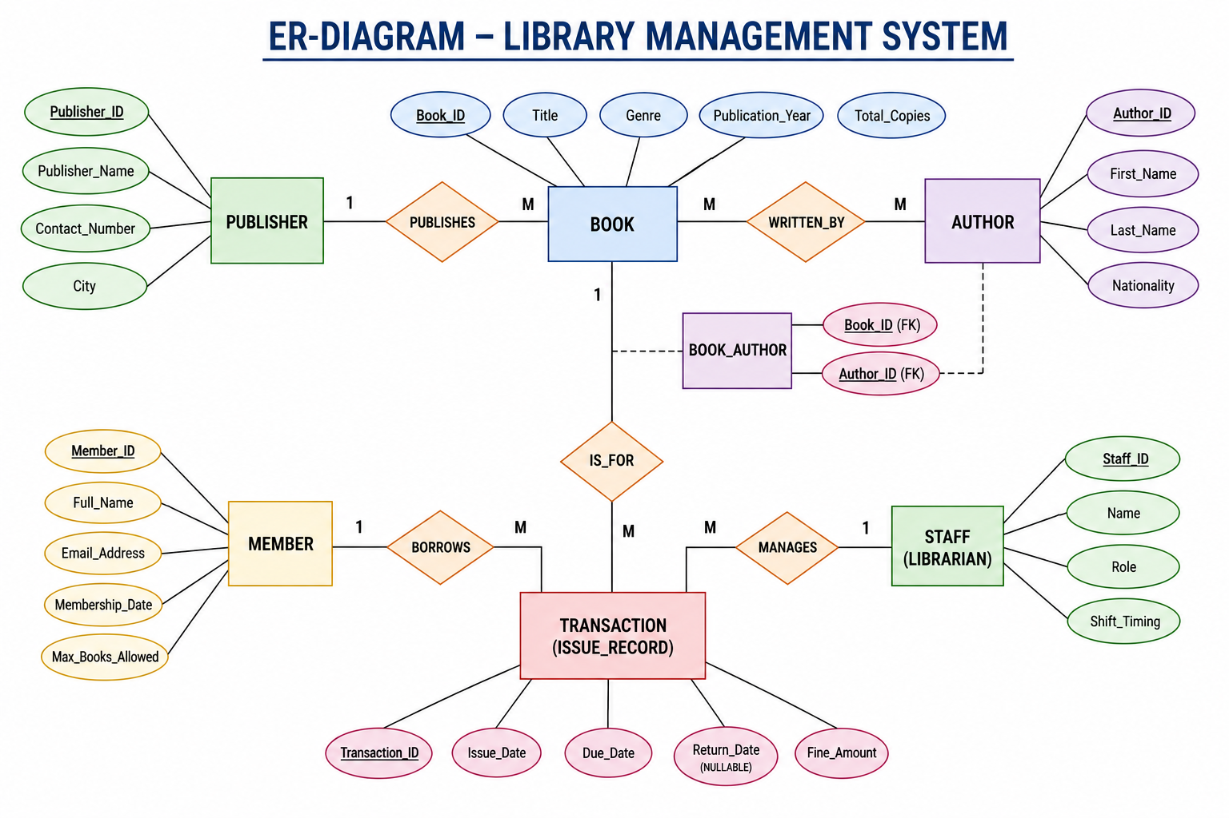

Fig. 3.1: ER Diagram of the Library Management System

3.4 Relationships and Cardinality
Table 3.3: Relationships and Cardinality
z | Relationship | Entity 2 | Cardinality (1:1 / 1:N / M:N) | Participation
PUBLISHER | Publishes | BOOK | 1:M | Total on BOOK, Partial on PUBLISHER
BOOK | Written By | AUTHOR | M:N | Total on BOOK, Total on AUTHOR
MEMBER | Borrows | TRANSACTION | 1:M | Partial on MEMBER, Total on TRANSACTION
BOOK | Is For | TRANSACTION | 1:M | Partial on BOOK, Total on TRANSACTION
STAFF | Manages | TRANSACTION | 1:M | Partial on STAFF, Total on TRANSACTION

3.5 Relational Database Schema
Table 3.4: Relational Database Schema
Table Name | Column Name | Data Type | Key (PK / FK / —) | Constraints
PUBLISHER | Publisher_ID | INT | PK | AUTO_INCREMENT
 | Publisher_Name | VARCHAR(100) | — | NOT NULL, UNIQUE
 | Contact_Number | VARCHAR(15) | — | NOT NULL
 | City | VARCHAR(50) | — | NOT NULL
AUTHOR | Author_ID | INT | PK | AUTO_INCREMENT
 | First_Name | VARCHAR(50) | — | NOT NULL
 | Last_Name | VARCHAR(50) | — | NOT NULL
 | Nationality | VARCHAR(50) | — | NOT NULL
BOOK | Book_ID | INT | PK | AUTO_INCREMENT
 | Title | VARCHAR(150) | — | NOT NULL
 | Genre | VARCHAR(50) | — | NOT NULL
 | Publication_Year | INT | — | CHECK (Publication_Year >= 1900)
 | Total_Copies | INT | — | CHECK (Total_Copies >= 0)
 | Available_Copies | INT | — | CHECK (Available_Copies >= 0)
 | Publisher_ID | INT | FK | NOT NULL, REFERENCES PUBLISHER
BOOK_AUTHOR | Book_ID | INT | PK, FK | REFERENCES BOOK(Book_ID)
 | Author_ID | INT | PK, FK | REFERENCES AUTHOR(Author_ID)
MEMBER | Member_ID | INT | PK | AUTO_INCREMENT
 | Full_Name | VARCHAR(100) | — | NOT NULL
 | Email_Address | VARCHAR(100) | — | NOT NULL, UNIQUE
 | Membership_Date | DATE | — | NOT NULL
 | Max_Books_Allowed | INT | — | DEFAULT 3, CHECK (Max_Books_Allowed > 0)
STAFF | Staff_ID | INT | PK | AUTO_INCREMENT
 | Name | VARCHAR(100) | — | NOT NULL
 | Role | VARCHAR(50) | — | NOT NULL
 | Shift_Timing | VARCHAR(30) | — | NOT NULL
TRANSACTION | Transaction_ID | INT | PK | AUTO_INCREMENT
 | Book_ID | INT | FK | NOT NULL, REFERENCES BOOK
 | Member_ID | INT | FK | NOT NULL, REFERENCES MEMBER
 | Staff_ID | INT | FK | NOT NULL, REFERENCES STAFF
 | Issue_Date | DATE | — | NOT NULL
 | Due_Date | DATE | — | NOT NULL, CHECK (Due_Date >= Issue_Date)
 | Return_Date | DATE | — | NULL
 | Fine_Amount | DECIMAL(8,2) | — | DEFAULT 0.00, CHECK (Fine_Amount >= 0.00)

Schema Diagram

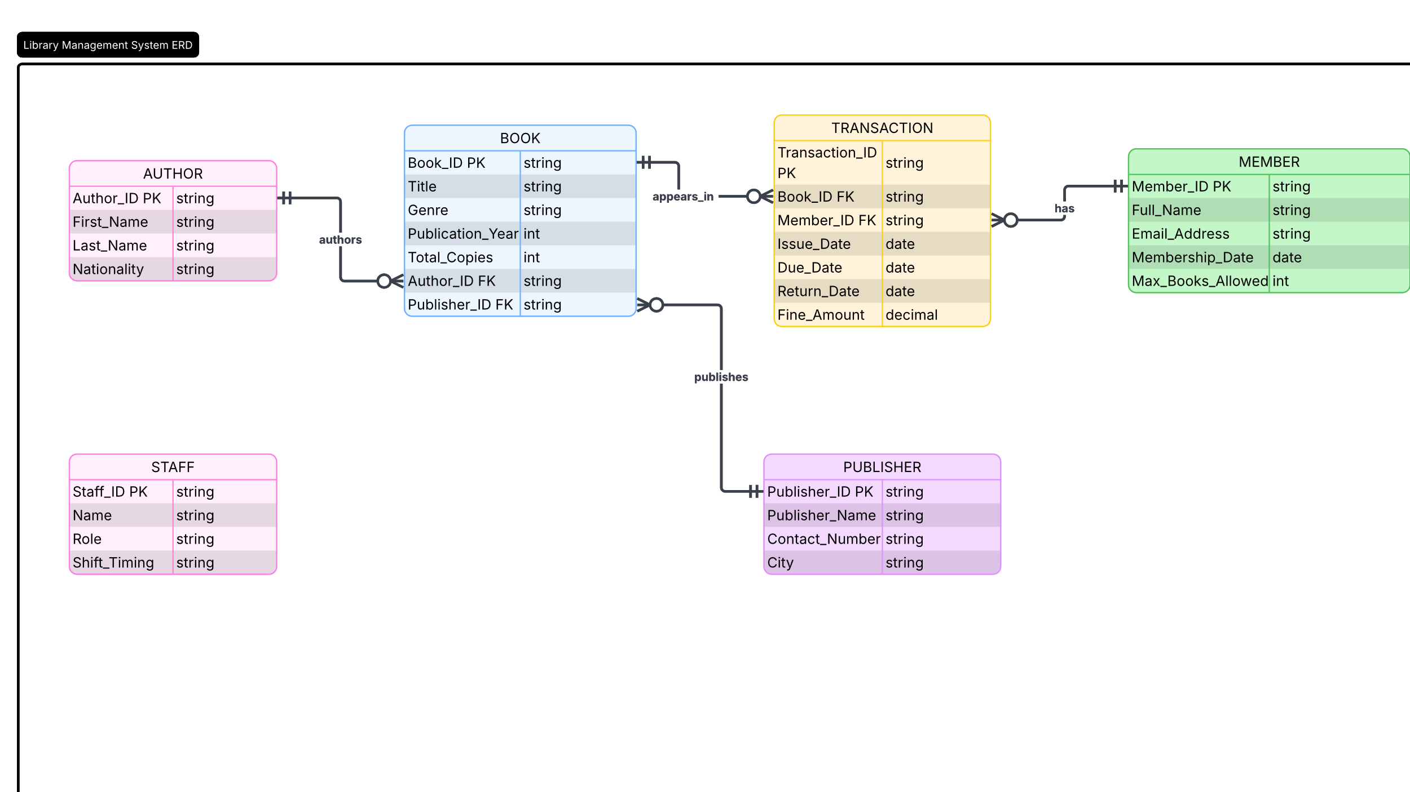

Fig. 3.2: Relational Schema Diagram

3.6 Primary Keys and Foreign Keys
Table 3.5: Primary Key and Foreign Key Definitions
Table | Primary Key | Foreign Key | References (Table.Column)
PUBLISHER | Publisher_ID | None | N/A
AUTHOR | Author_ID | None | N/A
BOOK | Book_ID | Publisher_ID | PUBLISHER(Publisher_ID)
BOOK_AUTHOR | (Book_ID, Author_ID) | Book_ID, Author_ID | BOOK(Book_ID), AUTHOR(Author_ID)
MEMBER | Member_ID | None | N/A
STAFF | Staff_ID | None | N/A
TRANSACTION | Transaction_ID | Book_ID, Member_ID, Staff_ID | BOOK(Book_ID), MEMBER(Member_ID), STAFF(Staff_ID)

3.7 Normalization up to 3NF
UNF → 1NF → 2NF → 3NF
- UNF: A single flat sheet containing books, multiple authors per cell, publisher contact information, and borrowing histories.
- 1NF: Ensured atomic attributes (separated author names into individual records) and created composite identifiers.
- 2NF: Eliminated partial dependencies where attributes like book titles depended solely on Book_ID rather than the composite key (Book_ID, Member_ID).
- 3NF: Eliminated transitive dependencies where publisher contact details depended on Publisher_ID, which was dependent on Book_ID. Publisher details were separated into their own table.
Table 3.6: Normalization Steps
Normal Form | Condition Satisfied | Anomaly Removed | Resulting Tables
1NF | Atomic domains, eliminated repeating author groups. | Multi-valued repeating groups removed. | Flattened Library Relation
2NF | In 1NF and no partial dependencies on composite keys. | Update anomalies during multiple checkouts removed. | BOOK, MEMBER, AUTHOR, TRANSACTION
3NF | In 2NF and no transitive functional dependencies (X → Y → Z). | Redundant publisher phone/city and role data removed. | BOOK, AUTHOR, PUBLISHER, MEMBER, STAFF, TRANSACTION, BOOK_AUTHOR

CHAPTER 4: DATABASE IMPLEMENTATION
(Deliverables of Review – II)

4.1 Database and Table Creation – DDL
[ Paste the CREATE TABLE script here ]
DROP DATABASE IF EXISTS LibraryManagementDB;
CREATE DATABASE LibraryManagementDB;
USE LibraryManagementDB;

-- 1. Publisher Table
CREATE TABLE PUBLISHER (
Publisher_ID INT AUTO_INCREMENT PRIMARY KEY,
Publisher_Name VARCHAR(100) NOT NULL UNIQUE,
Contact_Number VARCHAR(15) NOT NULL,
City VARCHAR(50) NOT NULL
);

-- 2. Author Table
CREATE TABLE AUTHOR (
Author_ID INT AUTO_INCREMENT PRIMARY KEY,
First_Name VARCHAR(50) NOT NULL,
Last_Name VARCHAR(50) NOT NULL,
Nationality VARCHAR(50) NOT NULL
);

-- 3. Book Table
CREATE TABLE BOOK (
Book_ID INT AUTO_INCREMENT PRIMARY KEY,
Title VARCHAR(150) NOT NULL,
Genre VARCHAR(50) NOT NULL,
Publication_Year INT NOT NULL CHECK (Publication_Year >= 1900),
Total_Copies INT NOT NULL CHECK (Total_Copies >= 0),
Available_Copies INT NOT NULL CHECK (Available_Copies >= 0),
Publisher_ID INT NOT NULL,
CONSTRAINT chk_stock_logic CHECK (Available_Copies <= Total_Copies),
CONSTRAINT fk_book_publisher FOREIGN KEY (Publisher_ID) REFERENCES PUBLISHER(Publisher_ID) ON DELETE RESTRICT ON UPDATE CASCADE
);

-- 4. Book_Author Junction Table
CREATE TABLE BOOK_AUTHOR (
Book_ID INT NOT NULL,
Author_ID INT NOT NULL,
PRIMARY KEY (Book_ID, Author_ID),
CONSTRAINT fk_ba_book FOREIGN KEY (Book_ID) REFERENCES BOOK(Book_ID) ON DELETE CASCADE ON UPDATE CASCADE,
CONSTRAINT fk_ba_author FOREIGN KEY (Author_ID) REFERENCES AUTHOR(Author_ID) ON DELETE CASCADE ON UPDATE CASCADE
);

-- 5. Member Table
CREATE TABLE MEMBER (
Member_ID INT AUTO_INCREMENT PRIMARY KEY,
Full_Name VARCHAR(100) NOT NULL,
Email_Address VARCHAR(100) NOT NULL UNIQUE,
Membership_Date DATE NOT NULL,
Max_Books_Allowed INT DEFAULT 3 CHECK (Max_Books_Allowed > 0)
);

-- 6. Staff Table
CREATE TABLE STAFF (
Staff_ID INT AUTO_INCREMENT PRIMARY KEY,
Name VARCHAR(100) NOT NULL,
Role VARCHAR(50) NOT NULL,
Shift_Timing VARCHAR(30) NOT NULL
);

-- 7. Transaction Table
CREATE TABLE TRANSACTION (
Transaction_ID INT AUTO_INCREMENT PRIMARY KEY,
Book_ID INT NOT NULL,
Member_ID INT NOT NULL,
Staff_ID INT NOT NULL,
Issue_Date DATE NOT NULL,
Due_Date DATE NOT NULL,
Return_Date DATE NULL,
Fine_Amount DECIMAL(8,2) DEFAULT 0.00 CHECK (Fine_Amount >= 0.00),
CONSTRAINT chk_trans_dates CHECK (Due_Date >= Issue_Date),
CONSTRAINT fk_trans_book FOREIGN KEY (Book_ID) REFERENCES BOOK(Book_ID) ON DELETE RESTRICT ON UPDATE CASCADE,
CONSTRAINT fk_trans_member FOREIGN KEY (Member_ID) REFERENCES MEMBER(Member_ID) ON DELETE RESTRICT ON UPDATE CASCADE,
CONSTRAINT fk_trans_staff FOREIGN KEY (Staff_ID) REFERENCES STAFF(Staff_ID) ON DELETE RESTRICT ON UPDATE CASCADE
);

-- B-Tree Performance Indexes
CREATE INDEX idx_book_genre ON BOOK(Genre, Title);
CREATE INDEX idx_trans_dates ON TRANSACTION(Issue_Date, Due_Date, Return_Date);

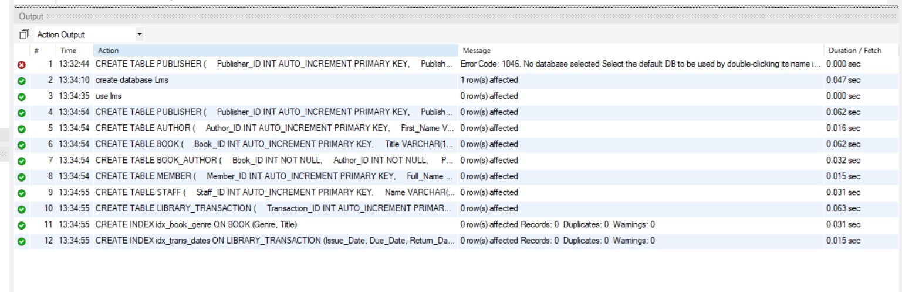

Fig. 4.1: Successful Creation of Tables
4.2 Sample Data Insertion – DML
Table 4.1: Sample Data Summary
S.No | Table Name | No. of Records Inserted | Purpose / Scope
1 | PUBLISHER | 5 | Leading academic publishers across India.
2 | AUTHOR | 6 | Standard academic authors and researchers.
3 | BOOK | 7 | Representative catalog titles across CS and AI.
4 | BOOK_AUTHOR | 7 | Multi-author associations resolving the M:N relationship.
5 | MEMBER | 6 | Student member profiles.
6 | STAFF | 3 | Circulation desk officers and library administrators.
7 | TRANSACTION | 7 | Active, returned, and overdue borrowing transactions.

-- Insert Publishers
INSERT INTO PUBLISHER (Publisher_Name, Contact_Number, City) VALUES
('Pearson Education', '022-26543210', 'Mumbai'),
('McGraw-Hill Education', '011-45678901', 'New Delhi'),
('MIT Press', '080-34567890', 'Bengaluru'),
('O''Reilly Media', '044-89012345', 'Chennai'),
('Oxford University Press', '040-67890123', 'Hyderabad');

-- Insert Authors
INSERT INTO AUTHOR (First_Name, Last_Name, Nationality) VALUES
('Abraham', 'Silberschatz', 'American'),
('Peter', 'Galvin', 'American'),
('Stuart', 'Russell', 'British'),
('Peter', 'Norvig', 'American'),
('Thomas', 'Cormen', 'American'),
('Ian', 'Goodfellow', 'Canadian');

-- Insert Books
INSERT INTO BOOK (Title, Genre, Publication_Year, Total_Copies, Available_Copies, Publisher_ID) VALUES
('Database System Concepts', 'Computer Science', 2019, 10, 8, 2),
('Artificial Intelligence: A Modern Approach', 'Artificial Intelligence', 2020, 8, 6, 1),
('Introduction to Algorithms', 'Algorithms', 2022, 12, 10, 3),
('Operating System Concepts', 'Computer Science', 2018, 6, 5, 2),
('Computer Networks', 'Networking', 2021, 5, 4, 1),
('Designing Data-Intensive Applications', 'Database Systems', 2017, 7, 7, 4),
('Deep Learning', 'Artificial Intelligence', 2016, 6, 5, 3);

-- Insert Book-Author Associations
INSERT INTO BOOK_AUTHOR (Book_ID, Author_ID) VALUES
(1, 1), (2, 3), (2, 4), (3, 5), (4, 1), (4, 2), (7, 6);

-- Insert Members (Using Project Team Names)
INSERT INTO MEMBER (Full_Name, Email_Address, Membership_Date, Max_Books_Allowed) VALUES
('B Vyas Sri Nandan', 'vyas.25ai@aditya.ac.in', '2025-08-01', 5),
('M Ravi Teja', 'ravi.25ai@aditya.ac.in', '2025-08-01', 5),
('Ch Karthikeyan', 'karthi.25ai@aditya.ac.in', '2025-08-01', 5),
('K A V Manikanta', 'mani.25ai@aditya.ac.in', '2025-08-01', 5),
('Sita Kumari', 'sita.25cs@aditya.ac.in', '2025-09-10', 3),
('Praveen Kumar', 'prav.25ec@aditya.ac.in', '2025-09-12', 3);

-- Insert Staff
INSERT INTO STAFF (Name, Role, Shift_Timing) VALUES
('Suresh Babu', 'Chief Librarian', 'Morning (08:00 - 16:00)'),
('Lakshmi Prasanna', 'Assistant Librarian', 'Evening (12:00 - 20:00)'),
('K. Ramanaji', 'Circulation Officer', 'Morning (08:00 - 16:00)');

-- Insert Transactions
INSERT INTO TRANSACTION (Book_ID, Member_ID, Staff_ID, Issue_Date, Due_Date, Return_Date, Fine_Amount) VALUES
(1, 1, 2, '2026-08-01', '2026-08-15', '2026-08-14', 0.00),
(1, 2, 2, '2026-08-10', '2026-08-24', '2026-08-31', 35.00),
(2, 3, 3, '2026-09-01', '2026-09-15', NULL, 65.00),
(3, 4, 2, '2026-09-15', '2026-09-29', NULL, 0.00),
(2, 1, 1, '2026-09-10', '2026-09-24', NULL, 20.00),
(4, 5, 2, '2026-09-18', '2026-10-02', NULL, 0.00),
(5, 6, 3, '2026-09-19', '2026-10-03', NULL, 0.00);

Fig. 4.2: Sample Data Inserted into the Tables

4.3 Constraints and Data Integrity
Table 4.2: Constraints and Data Integrity Rules
Constraint / Validation | Applied On (Table.Column) | Purpose | Evidence / Error Returned
PRIMARY KEY | All Tables (*_ID) | Uniquely identifies each record. | Error 1062: Duplicate entry
FOREIGN KEY | TRANSACTION.Book_ID, TRANSACTION.Member_ID | Enforces referential integrity between loans and master entities. | Error 1452: Cannot add or update a child row
CHECK | BOOK.Available_Copies <= Total_Copies | Prevents available inventory from exceeding physical stock. | Error 3819: Check constraint 'chk_stock_logic' violated
CHECK | TRANSACTION.Fine_Amount >= 0.00 | Prevents negative fine assessments. | Rejects negative financial values
CHECK | TRANSACTION.Due_Date >= Issue_Date | Prevents logically invalid due dates. | Enforces forward-dated returns
UNIQUE | MEMBER.Email_Address | Prevents duplicate accounts per student. | Rejects matching email insertions

4.4 Data Validation Rules
Data corruption is prevented through referential restrict policies (ON DELETE RESTRICT). Attempting to delete a member who has unreturned books triggers a foreign key rejection:
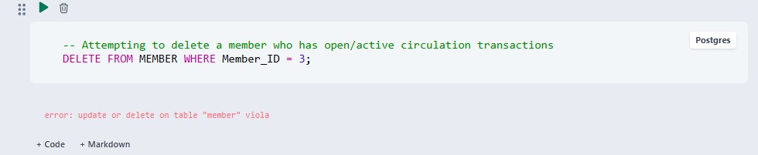

Fig. 4.3: Referential Integrity Enforced by the Database

CHAPTER 5: SQL OPERATIONS AND QUERIES

5.1 DQL – Basic Retrieval Queries
Table 5.1: Basic Retrieval Queries
Q.No | Purpose of the Query | SQL Statement | Output Ref.
Q1 | Retrieve all members eligible to borrow up to 5 books. | SELECT Member_ID, Full_Name, Email_Address FROM MEMBER WHERE Max_Books_Allowed = 5; | Fig. 5.1
Q2 | List books where available stock is 5 or fewer. | SELECT Book_ID, Title, Genre, Available_Copies FROM BOOK WHERE Available_Copies <= 5; | Fig. 5.2
Q3 | Display all distinct literary genres in the catalog. | SELECT DISTINCT Genre FROM BOOK; | Fig. 5.3
Q4 | List active open book loans (not yet returned). | SELECT Transaction_ID, Book_ID, Member_ID, Due_Date FROM TRANSACTION WHERE Return_Date IS NULL; | Fig. 5.4

5.2 Join Operations
Table 5.2: Join Operations
Q.No | Type of Join | SQL Statement | Output Ref.
Q5 | Inner Join: Retrieve books along with their publisher names. | SELECT b.Title, p.Publisher_Name, b.Genre FROM BOOK b INNER JOIN PUBLISHER p ON b.Publisher_ID = p.Publisher_ID; | Fig. 5.5
Q6 | Equi Join: List members alongside the titles of books they borrowed. | SELECT m.Full_Name, b.Title, t.Issue_Date, t.Due_Date FROM MEMBER m, TRANSACTION t, BOOK b WHERE m.Member_ID = t.Member_ID AND b.Book_ID = t.Book_ID; | Fig. 5.6
Q7 | Left Outer Join: Show all books and any active transactions. | SELECT b.Title, t.Transaction_ID, t.Return_Date FROM BOOK b LEFT JOIN TRANSACTION t ON b.Book_ID = t.Book_ID; | Fig. 5.7
Q8 | Right Outer Join: Show all staff members and transactions authorized by them. | SELECT s.Name AS Staff_Name, t.Transaction_ID, t.Issue_Date FROM TRANSACTION t RIGHT JOIN STAFF s ON t.Staff_ID = s.Staff_ID; | Fig. 5.8
Q9 | Full Outer Join Emulation: Unified view of publishers and books. | SELECT p.Publisher_Name, b.Title FROM PUBLISHER p LEFT JOIN BOOK b ON p.Publisher_ID = b.Publisher_ID  UNION  SELECT p.Publisher_Name, b.Title FROM PUBLISHER p RIGHT JOIN BOOK b ON p.Publisher_ID = b.Publisher_ID; | Fig. 5.9

5.3 Aggregate Functions, GROUP BY and HAVING
Table 5.3: Aggregate, GROUP BY and HAVING Queries
Q.No | Function Used | SQL Statement | Output Ref.
Q10 | COUNT(), GROUP BY: Count total titles published by each publisher. | SELECT p.Publisher_Name, COUNT(b.Book_ID) AS Total_Books FROM PUBLISHER p LEFT JOIN BOOK b ON p.Publisher_ID = b.Publisher_ID GROUP BY p.Publisher_Name; | Fig. 5.10
Q11 | SUM(), AVG(): Total fines collected and average fine per loan. | SELECT SUM(Fine_Amount) AS Total_Fines, AVG(Fine_Amount) AS Avg_Fine FROM TRANSACTION WHERE Fine_Amount > 0; | Fig. 5.11
Q12 | GROUP BY, HAVING: Members who have borrowed more than one book. | SELECT Member_ID, COUNT(Transaction_ID) AS Total_Borrows FROM TRANSACTION GROUP BY Member_ID HAVING COUNT(Transaction_ID) > 1; | Fig. 5.12

5.4 Nested and Correlated Subqueries
Table 5.4: Subqueries
Q.No | Type (Nested / Correlated) | SQL Statement | Output Ref.
Q13 | Nested Subquery (IN): Find all members with overdue books. | SELECT Full_Name, Email_Address FROM MEMBER WHERE Member_ID IN (SELECT Member_ID FROM TRANSACTION WHERE Return_Date IS NULL AND Due_Date < CURDATE()); | Fig. 5.13
Q14 | Correlated Subquery: Books with fewer copies than the average in their genre. | SELECT b1.Title, b1.Genre, b1.Available_Copies FROM BOOK b1 WHERE b1.Available_Copies < (SELECT AVG(b2.Available_Copies) FROM BOOK b2 WHERE b2.Genre = b1.Genre); | Fig. 5.14

5.5 Views and Relational Set Operations
Table 5.5: Views and Set Operations
Q.No | View / Set Operation | SQL Statement | Output Ref.
Q15 | Updatable View: Public search view exposing titles and availability. | CREATE VIEW V_AvailableBooks AS SELECT Book_ID, Title, Genre, Available_Copies FROM BOOK WHERE Available_Copies > 0; | Fig. 5.15
Q16 | Non-Updatable View: Administrative fine and loan overview. | CREATE VIEW V_MemberFineSummary AS SELECT m.Member_ID, m.Full_Name, SUM(t.Fine_Amount) AS Total_Due FROM MEMBER m JOIN TRANSACTION t ON m.Member_ID = t.Member_ID GROUP BY m.Member_ID, m.Full_Name; | Fig. 5.16
Q17 | UNION: Master institutional directory of members and staff emails. | SELECT Email_Address AS Email, 'Member' AS User_Type FROM MEMBER  UNION  SELECT 'suresh.lib@aditya.ac.in', 'Staff' FROM DUAL; | Fig. 5.17
Q18 | INTERSECT Emulation: AI books published by MIT Press. | SELECT Title FROM BOOK WHERE Genre = 'Artificial Intelligence' AND Publisher_ID IN (SELECT Publisher_ID FROM PUBLISHER WHERE Publisher_Name = 'MIT Press'); | Fig. 5.18

5.6 DCL and TCL Operations
Table 5.6: DCL and TCL Operations
Q.No | Command | Purpose | SQL Statement | Output Ref.
Q19 | GRANT | Grant catalog read access to circulation clerks. | GRANT SELECT ON LibraryManagementDB.V_AvailableBooks TO 'clerk_user'@'localhost'; | Fig. 5.19
Q20 | REVOKE | Remove catalog deletion permissions from assistant roles. | REVOKE DELETE ON LibraryManagementDB.BOOK FROM 'clerk_user'@'localhost'; | Fig. 5.20
Q21 | COMMIT & ROLLBACK | Transaction ensuring book issue and stock decrement execute atomically. | START TRANSACTION;  INSERT INTO TRANSACTION (Book_ID, Member_ID, Staff_ID, Issue_Date, Due_Date) VALUES (3, 1, 1, CURDATE(), DATE_ADD(CURDATE(), INTERVAL 14 DAY));  UPDATE BOOK SET Available_Copies = Available_Copies - 1 WHERE Book_ID = 3;  COMMIT; | Fig. 5.21

CHAPTER 6: MODULES AND FUNCTIONALITIES
Table 6.1: Modules and Their Functionalities
S.No | Module Name | Functionality | Tables Involved
1 | Catalog Management | Tracks books, multi-author attributions, publishers, genres, and stock levels. | BOOK, AUTHOR, PUBLISHER, BOOK_AUTHOR
2 | Patron/Member Module | Registers members, maintains email records, and monitors borrowing limits. | MEMBER
3 | Staff Administration | Stores library staff directory, assigned roles, and working shifts. | STAFF
4 | Circulation Module | Handles checkout, due-date calculation, and check-in workflows. | TRANSACTION, BOOK, MEMBER
5 | Fine & Audit Management | Tracks overdue periods, computes daily penalties, and records payments. | TRANSACTION, MEMBER

Catalog Management Module:
Organizes library resources by linking books to publishers and authors via BOOK_AUTHOR. It maintains stock counts and ensures data consistency across editions.
Patron Module: Handles user registration, issues digital cards, and limits borrowing based on member tiers.
Staff Administration Module: Logs staff authorizations on transactions, ensuring operational accountability.
Circulation Module: Manages active loans, calculates returns, and connects patrons to physical inventory.
Fine & Audit Module: Automatically computes late return penalties and flags overdue patrons.

CHAPTER 7: RESULTS – SAMPLE OUTPUTS AND SCREENSHOTS

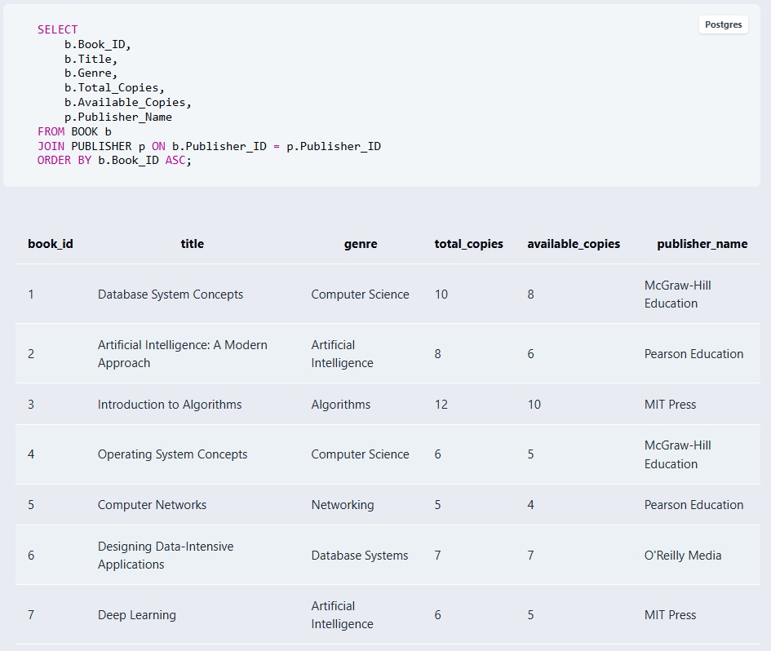
Fig. 7.1: Active Master Catalog and Available Copy Status

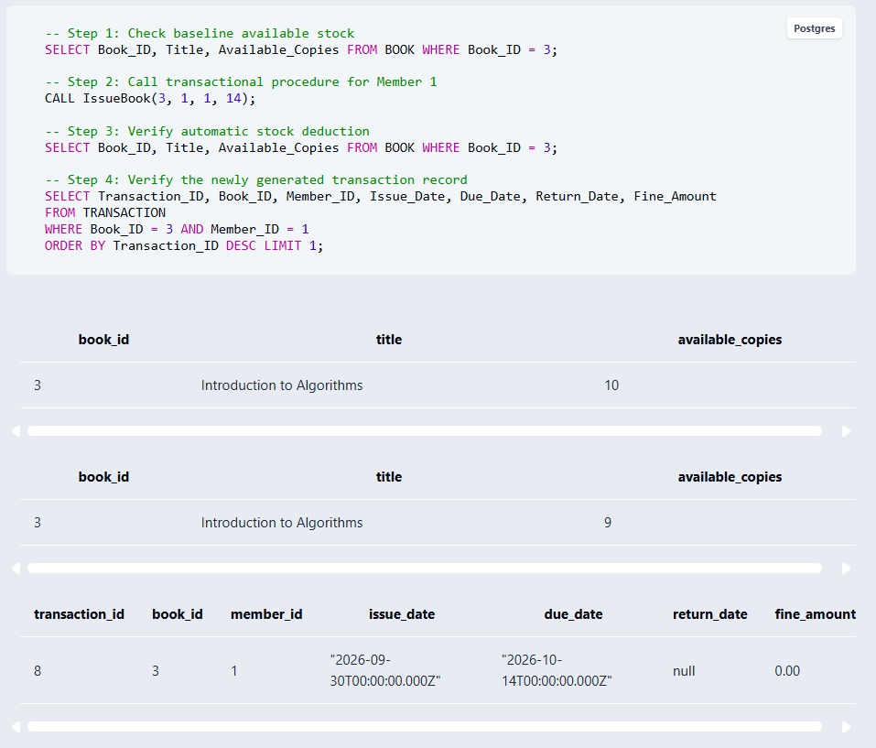

Fig. 7.2: Execution of IssueBook Procedure and Trigger Inventory Synchronization

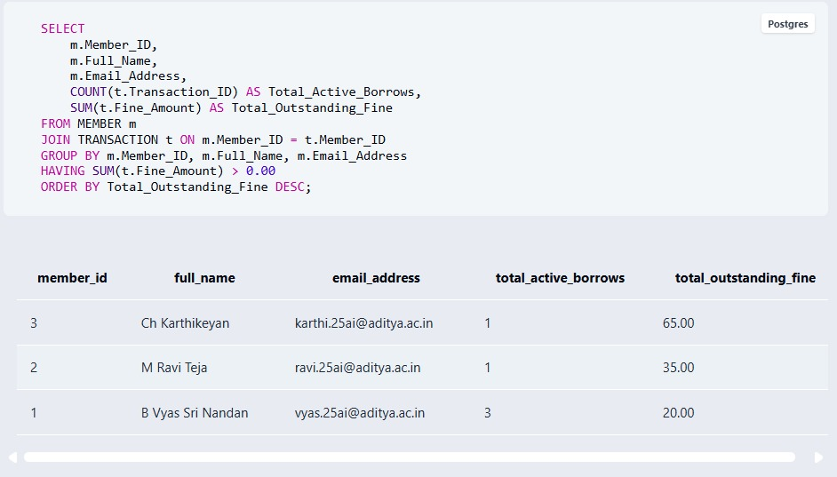

Fig. 7.3: Patron Fine Summary and Overdue Audit Report

Purpose: Proves that the database storage engine rejects invalid modifications that violate foreign keys or logical domain constraints (CHECK, RESTRICT).
SQL Query Executed (Case A: Deletion Restriction):

SQL Query Executed (Case B: Illogical Inventory Check Constraint):
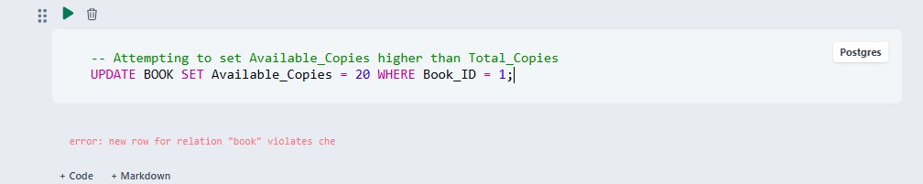

Fig. 7.4: Referential Integrity and Domain Check Constraints Enforced by MySQL Engine

CHAPTER 8: TESTING AND DATA VALIDATION
Table 8.1: Test Cases and Results
TC No. | Test Case Description | Input / Action | Expected Result | Actual Result | Status
TC01 | Duplicate Member Email | Insert MEMBER with existing email address. | Reject insertion with Duplicate entry error. | Error 1062 (23000) returned. | PASS
TC02 | Invalid Inventory Logic | Set Available_Copies = 15 where Total_Copies = 10. | Reject update via chk_stock_logic constraint. | Error 3819 Check constraint violated. | PASS
TC03 | Negative Fine Rejection | Insert Fine_Amount = -25.00 in TRANSACTION. | Rejection via CHECK (Fine_Amount >= 0). | Error 3819 Check constraint violated. | PASS
TC04 | Chronological Date Logic | Insert Due_Date < Issue_Date in TRANSACTION. | Rejection via chk_trans_dates constraint. | Rejected by MySQL Engine. | PASS
TC05 | Orphan Record Prevention | Delete MEMBER record with active transactions. | Block deletion via ON DELETE RESTRICT. | Error 1451 Foreign Key Constraint Fails. | PASS
TC06 | Quota Limit Enforcement | Call IssueBook when borrowing quota is exceeded. | Transaction rollback with custom error message. | Error: Borrowing limit exceeded. | PASS

CHAPTER 9: GITHUB REPOSITORY AND TEAM CONTRIBUTION

9.1 Repository Details
GitHub Repository Link: http://github.com/KAV-Manikanta/DBMS-PROJECT---LIBRARY-MANAGEMENT-SYSTEM

9.2 Team Responsibilities and Contribution
Table 9.1: Team Responsibilities
S.No | Student Name | Roll Number | Role / Responsibility | Modules Contributed
1 | B Vyas Sri Nandan | 25B11AI130 | Project Lead & Schema Architect | ER Modeling, 3NF Normalization, DDL & DML Scripts
2 | M Ravi Teja | 25B11AI755 | Backend Database Developer | Triggers, Stored Procedures, ACID Transactions
3 | Ch Karthikeyan | 25B11AI216 | Query & Analytics Specialist | Joins, Subqueries, Analytical Views, Performance Tuning
4 | K A V Manikanta | 25B11AI589 | Testing & Documentation Lead | Test Case Execution, GitHub Management, Final Report

9.3 Review-wise Progress
Table 9.2: Review-wise Progress Record
Review | Date | Deliverables Presented | Remarks of the Guide
Review 1 | August 2026 | Problem Statement, Scope, Entities, Attributes, ER Diagram, Relational Schema | Schema design approved; advised to proceed to normalization and procedural SQL
Review 2 | November 2026 | Physical DDL, DML data seeding, Triggers, ACID Stored Procedures, Views, Complex Queries, Testing Matrix. | Implementation validated successfully; performance and integrity verified.

CHAPTER 10: CONCLUSION AND FUTURE ENHANCEMENTS

10.1 Conclusion
The Library Management System provides a normalized relational database solution on MySQL 8.0. The system includes seven core tables structured to Third Normal Form (3NF) to eliminate data redundancy and modification anomalies. Declarative constraints maintain entity and referential integrity across all operational workflows. Procedural triggers synchronize book inventory counts upon issue and return, and transaction blocks enforce ACID compliance. Relational views, joins, and aggregate reports support library administration queries.

10.2 Limitations of the Present Work
- The system does not interface with physical RFID smart barriers or automated return dropboxes.
- Payments are logged as monetary values rather than communicating with banking payment gateways.
- Digital books, PDFs, and multimedia streaming are not managed within this relational schema.

10.3 Future Enhancements
- Developing a web-based dashboard using Flask or Streamlit with role-based member logins.
- Adding an automated SMS/Email notification system using scheduled events to alert patrons about upcoming return deadlines.
- Integrating machine learning algorithms to recommend new books based on borrowing history.

REFERENCES
- Abraham Silberschatz, Henry F. Korth and S. Sudarshan, “Database System Concepts”, 8th Edition, McGraw-Hill, ISBN: 978-1260230508.
- Raghurama Krishnan and Johannes Gehrke, “Database Management Systems”, 4th Edition, McGraw-Hill, ISBN: 978-1260091195.
- Ramez Elmasri and Shamkant B. Navathe, “Fundamentals of Database Systems”, 7th Edition, Pearson, ISBN: 978-0137504277.

APPENDIX A – COMPLETE SQL SCRIPT
-- =============================================================
-- APPENDIX A: COMPLETE SQL SCRIPT FOR LIBRARY MANAGEMENT SYSTEM
-- =============================================================
DROP DATABASE IF EXISTS LibraryManagementDB;
CREATE DATABASE LibraryManagementDB;
USE LibraryManagementDB;

-- 1. Table: PUBLISHER
CREATE TABLE PUBLISHER (
Publisher_ID INT AUTO_INCREMENT PRIMARY KEY,
Publisher_Name VARCHAR(100) NOT NULL UNIQUE,
Contact_Number VARCHAR(15) NOT NULL,
City VARCHAR(50) NOT NULL
);

-- 2. Table: AUTHOR
CREATE TABLE AUTHOR (
Author_ID INT AUTO_INCREMENT PRIMARY KEY,
First_Name VARCHAR(50) NOT NULL,
Last_Name VARCHAR(50) NOT NULL,
Nationality VARCHAR(50) NOT NULL
);

-- 3. Table: BOOK
CREATE TABLE BOOK (
Book_ID INT AUTO_INCREMENT PRIMARY KEY,
Title VARCHAR(150) NOT NULL,
Genre VARCHAR(50) NOT NULL,
Publication_Year INT NOT NULL CHECK (Publication_Year >= 1900),
Total_Copies INT NOT NULL CHECK (Total_Copies >= 0),
Available_Copies INT NOT NULL CHECK (Available_Copies >= 0),
Publisher_ID INT NOT NULL,
CONSTRAINT chk_stock_logic CHECK (Available_Copies <= Total_Copies),
CONSTRAINT fk_book_publisher FOREIGN KEY (Publisher_ID) REFERENCES PUBLISHER(Publisher_ID) ON DELETE RESTRICT ON UPDATE CASCADE
);

-- 4. Table: BOOK_AUTHOR (Junction Table)
CREATE TABLE BOOK_AUTHOR (
Book_ID INT NOT NULL,
Author_ID INT NOT NULL,
PRIMARY KEY (Book_ID, Author_ID),
CONSTRAINT fk_ba_book FOREIGN KEY (Book_ID) REFERENCES BOOK(Book_ID) ON DELETE CASCADE ON UPDATE CASCADE,
CONSTRAINT fk_ba_author FOREIGN KEY (Author_ID) REFERENCES AUTHOR(Author_ID) ON DELETE CASCADE ON UPDATE CASCADE
);

-- 5. Table: MEMBER
CREATE TABLE MEMBER (
Member_ID INT AUTO_INCREMENT PRIMARY KEY,
Full_Name VARCHAR(100) NOT NULL,
Email_Address VARCHAR(100) NOT NULL UNIQUE,
Membership_Date DATE NOT NULL,
Max_Books_Allowed INT DEFAULT 3 CHECK (Max_Books_Allowed > 0)
);

-- 6. Table: STAFF
CREATE TABLE STAFF (
Staff_ID INT AUTO_INCREMENT PRIMARY KEY,
Name VARCHAR(100) NOT NULL,
Role VARCHAR(50) NOT NULL,
Shift_Timing VARCHAR(30) NOT NULL
);
-- 7. Table: TRANSACTION
CREATE TABLE TRANSACTION (
Transaction_ID INT AUTO_INCREMENT PRIMARY KEY,
Book_ID INT NOT NULL,
Member_ID INT NOT NULL,
Staff_ID INT NOT NULL,
Issue_Date DATE NOT NULL,
Due_Date DATE NOT NULL,
Return_Date DATE NULL,
Fine_Amount DECIMAL(8,2) DEFAULT 0.00 CHECK (Fine_Amount >= 0.00),
CONSTRAINT chk_trans_dates CHECK (Due_Date >= Issue_Date),
CONSTRAINT fk_trans_book FOREIGN KEY (Book_ID) REFERENCES BOOK(Book_ID) ON DELETE RESTRICT ON UPDATE CASCADE,
CONSTRAINT fk_trans_member FOREIGN KEY (Member_ID) REFERENCES MEMBER(Member_ID) ON DELETE RESTRICT ON UPDATE CASCADE,
CONSTRAINT fk_trans_staff FOREIGN KEY (Staff_ID) REFERENCES STAFF(Staff_ID) ON DELETE RESTRICT ON UPDATE CASCADE
);

-- Performance Indexes
CREATE INDEX idx_book_genre ON BOOK(Genre, Title);
CREATE INDEX idx_trans_dates ON TRANSACTION(Issue_Date, Due_Date, Return_Date);

-- -------------------------------------------------------------
-- TRIGGERS FOR AUTOMATED DATA INTEGRITY
-- -------------------------------------------------------------

DELIMITER //

-- Trigger 1: Automatically decrement book stock on new loan
CREATE TRIGGER trg_after_issue_insert
AFTER INSERT ON TRANSACTION
FOR EACH ROW
BEGIN
UPDATE BOOK
SET Available_Copies = Available_Copies - 1
WHERE Book_ID = NEW.Book_ID;
END //

-- Trigger 2: Automatically increment stock and calculate fines on return
CREATE TRIGGER trg_after_return_update
AFTER UPDATE ON TRANSACTION
FOR EACH ROW
BEGIN
DECLARE v_days_late INT DEFAULT 0;
DECLARE v_fine_rate DECIMAL(5,2) DEFAULT 5.00;

-- Execute only when book is newly returned
IF OLD.Return_Date IS NULL AND NEW.Return_Date IS NOT NULL THEN
-- 1. Restore book stock
UPDATE BOOK
SET Available_Copies = Available_Copies + 1
WHERE Book_ID = NEW.Book_ID;

-- 2. Calculate fine if returned after due date
IF NEW.Return_Date > NEW.Due_Date THEN
SET v_days_late = DATEDIFF(NEW.Return_Date, NEW.Due_Date);
UPDATE TRANSACTION
SET Fine_Amount = v_days_late * v_fine_rate
WHERE Transaction_ID = NEW.Transaction_ID;
END IF;
END IF;
END //

-- -------------------------------------------------------------
-- STORED PROCEDURE: TRANSACTIONAL BOOK ISSUE
-- -------------------------------------------------------------

CREATE PROCEDURE IssueBook(
IN p_book_id INT,
IN p_member_id INT,
IN p_staff_id INT,
IN p_duration_days INT
)
BEGIN
DECLARE v_stock INT;
DECLARE v_current_borrows INT;
DECLARE v_limit INT;

START TRANSACTION;

-- Check member limit
SELECT Max_Books_Allowed INTO v_limit FROM MEMBER WHERE Member_ID = p_member_id;
SELECT COUNT(*) INTO v_current_borrows FROM TRANSACTION WHERE Member_ID = p_member_id AND Return_Date IS NULL;

IF v_current_borrows >= v_limit THEN
ROLLBACK;
SIGNAL SQLSTATE '45000' SET MESSAGE_TEXT = 'Error: Patron has reached borrow limit.';
END IF;

-- Check stock with row lock
SELECT Available_Copies INTO v_stock FROM BOOK WHERE Book_ID = p_book_id FOR UPDATE;

IF v_stock <= 0 THEN
ROLLBACK;
SIGNAL SQLSTATE '45000' SET MESSAGE_TEXT = 'Error: Copy is out of stock.';
ELSE
INSERT INTO TRANSACTION (Book_ID, Member_ID, Staff_ID, Issue_Date, Due_Date, Return_Date, Fine_Amount)
VALUES (p_book_id, p_member_id, p_staff_id, CURDATE(), DATE_ADD(CURDATE(), INTERVAL p_duration_days DAY), NULL, 0.00);
COMMIT;
END IF;
END //

DELIMITER ;

-- -------------------------------------------------------------
-- SAMPLE DATA INSERTION (DML)
-- -------------------------------------------------------------

INSERT INTO PUBLISHER (Publisher_Name, Contact_Number, City) VALUES
('Pearson Education', '022-26543210', 'Mumbai'),
('McGraw-Hill Education', '011-45678901', 'New Delhi'),
('MIT Press', '080-34567890', 'Bengaluru'),
('O''Reilly Media', '044-89012345', 'Chennai'),
('Oxford University Press', '040-67890123', 'Hyderabad');

INSERT INTO AUTHOR (First_Name, Last_Name, Nationality) VALUES
('Abraham', 'Silberschatz', 'American'),
('Peter', 'Galvin', 'American'),
('Stuart', 'Russell', 'British'),
('Peter', 'Norvig', 'American'),
('Thomas', 'Cormen', 'American'),
('Ian', 'Goodfellow', 'Canadian');

INSERT INTO BOOK (Title, Genre, Publication_Year, Total_Copies, Available_Copies, Publisher_ID) VALUES
('Database System Concepts', 'Computer Science', 2019, 10, 8, 2),
('Artificial Intelligence: A Modern Approach', 'Artificial Intelligence', 2020, 8, 6, 1),
('Introduction to Algorithms', 'Algorithms', 2022, 12, 10, 3),
('Operating System Concepts', 'Computer Science', 2018, 6, 5, 2),
('Computer Networks', 'Networking', 2021, 5, 4, 1),
('Designing Data-Intensive Applications', 'Database Systems', 2017, 7, 7, 4),
('Deep Learning', 'Artificial Intelligence', 2016, 6, 5, 3);

INSERT INTO BOOK_AUTHOR (Book_ID, Author_ID) VALUES
(1, 1), (2, 3), (2, 4), (3, 5), (4, 1), (4, 2), (7, 6);

INSERT INTO MEMBER (Full_Name, Email_Address, Membership_Date, Max_Books_Allowed) VALUES
('B Vyas Sri Nandan', 'vyas.25ai@aditya.ac.in', '2025-08-01', 5),
('M Ravi Teja', 'ravi.25ai@aditya.ac.in', '2025-08-01', 5),
('Ch Karthikeyan', 'karthi.25ai@aditya.ac.in', '2025-08-01', 5),
('K A V Manikanta', 'mani.25ai@aditya.ac.in', '2025-08-01', 5),
('Sita Kumari', 'sita.25cs@aditya.ac.in', '2025-09-10', 3),
('Praveen Kumar', 'prav.25ec@aditya.ac.in', '2025-09-12', 3);

INSERT INTO STAFF (Name, Role, Shift_Timing) VALUES
('Suresh Babu', 'Chief Librarian', 'Morning (08:00 - 16:00)'),
('Lakshmi Prasanna', 'Assistant Librarian', 'Evening (12:00 - 20:00)'),
('K. Ramanaji', 'Circulation Officer', 'Morning (08:00 - 16:00)');
INSERT INTO TRANSACTION (Book_ID, Member_ID, Staff_ID, Issue_Date, Due_Date, Return_Date, Fine_Amount) VALUES
(1, 1, 2, '2026-08-01', '2026-08-15', '2026-08-14', 0.00),
(1, 2, 2, '2026-08-10', '2026-08-24', '2026-08-31', 35.00),
(2, 3, 3, '2026-09-01', '2026-09-15', NULL, 65.00),
(3, 4, 2, '2026-09-15', '2026-09-29', NULL, 0.00),
(2, 1, 1, '2026-09-10', '2026-09-24', NULL, 20.00),
(4, 5, 2, '2026-09-18', '2026-10-02', NULL, 0.00),
(5, 6, 3, '2026-09-19', '2026-10-03', NULL, 0.00);

-- Operational Views
CREATE VIEW V_AvailableBooks AS
SELECT Book_ID, Title, Genre, Available_Copies FROM BOOK WHERE Available_Copies > 0;

CREATE VIEW V_MemberFineSummary AS
SELECT m.Member_ID, m.Full_Name, SUM(t.Fine_Amount) AS Total_Due
FROM MEMBER m JOIN TRANSACTION t ON m.Member_ID = t.Member_ID
GROUP BY m.Member_ID, m.Full_Name;

